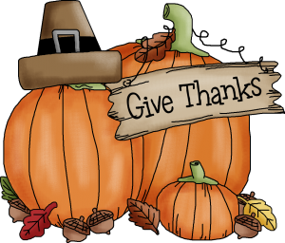
The 3 F’s – Food, Fun & Fellowship

“Together We Can Make It.” What a Better to Celebrate the Thanksgiving Holiday than with Our Al-Anon Family & Friends. Come Join Us for a Second Annual Thanksgiving PotluckMeeting &Fellowship. Bring Your Favorite Dish to Share.
This Event is Hosted by Thursday Stepping Stones AFG and For Additional Information Please Contact Mona S. at 302-266-4125 or deborahjane1310@gmail.com
When: Thanksgiving Day – November 23, 2017 from 10:30am – 3:00 pm
Agenda: 10:00 - 10:30 Fellowship & Set Up
10:30-11:30 Meeting
11:30-12:00 Fellowship
12:00-1:00 Meeting
1:00- 1:30 Fellowship
1:30 – 2:30 Meeting
2:30- 3:00 Fellowship & Clean up

Where: Greenhill Presbyterian Church
3112 Pennsylvania Avenue, Wilmington, DE 19807
Message from Lois W. one of the Al-Anon Co-founders
“It’s always forward that we have to look, and let our gratitude be for those to come. The people who have been in the past were just doing what they wanted to, what they loved to do – and what you yourselves are doing. So here’s to the future of Al-Anon!”

