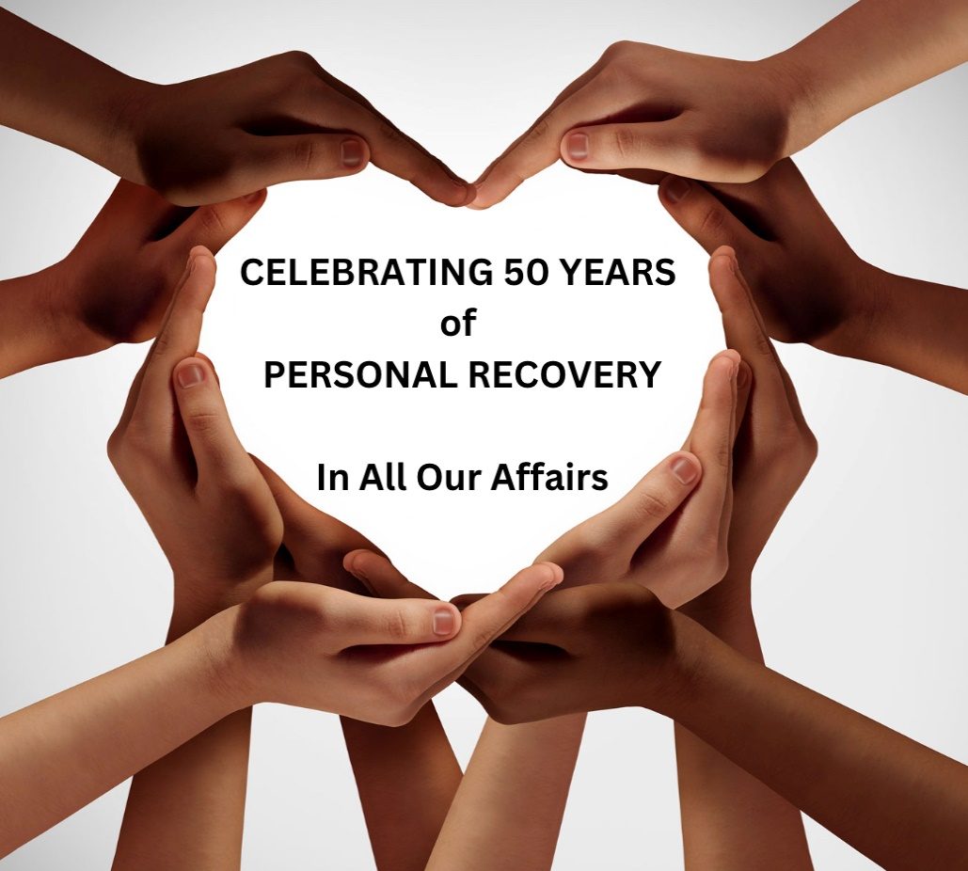

It’s Coming!
50th Annual Pennsylvania AFG Convention
at Susquehanna University, Selinsgrove, Pa.
June 9-11, 2023

Details are still being worked out, but we have the
Workshop Topics:
- Working the 12 Steps in 15 Minutes. (An interactive workshop using instructional handout sheets).
- Tuning In with the Traditions in the Family and the Group.
- Using the Al-Anon Tools for Recovery (CAL, Slogans, Steps and Traditions, Meetings, Sponsorship, Phone Calls, Prayer, Meditation, Service, Higher Power).
- Resentment: Holding On or Letting Go?
- Setting Boundaries: Focusing on Myself, Not Unacceptable Behaviors.
- Writing for The Forum: Reaching Others While Helping Myself.
- Transforming Loss & Grief Through Al-Anon.
- Embracing and Handling Conflict in Relationships at Home and Work.
Those attending the Convention who’d like to help with a workshop are invited to email convention.workshop@pa-al-anon.org for more information.

